**Sim Agent MPI**

Tyler Banks

Version 1.0

Contents

Quick Start 2

Notes 10

Obtaining an NSG-R account with API access 10

# Quick Start

1. Open **Sim Agent MPI**. Open your model by clicking ‘Select Directory’

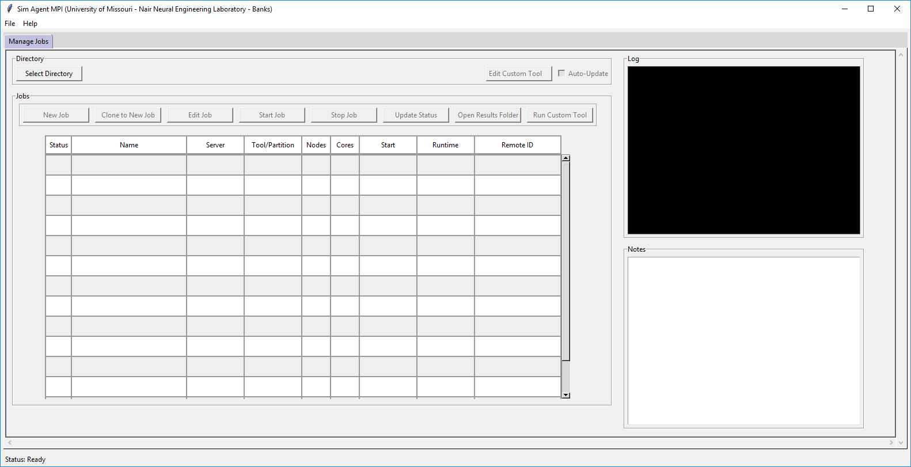

1. Find the folder with your project model and click ‘Select Folder’

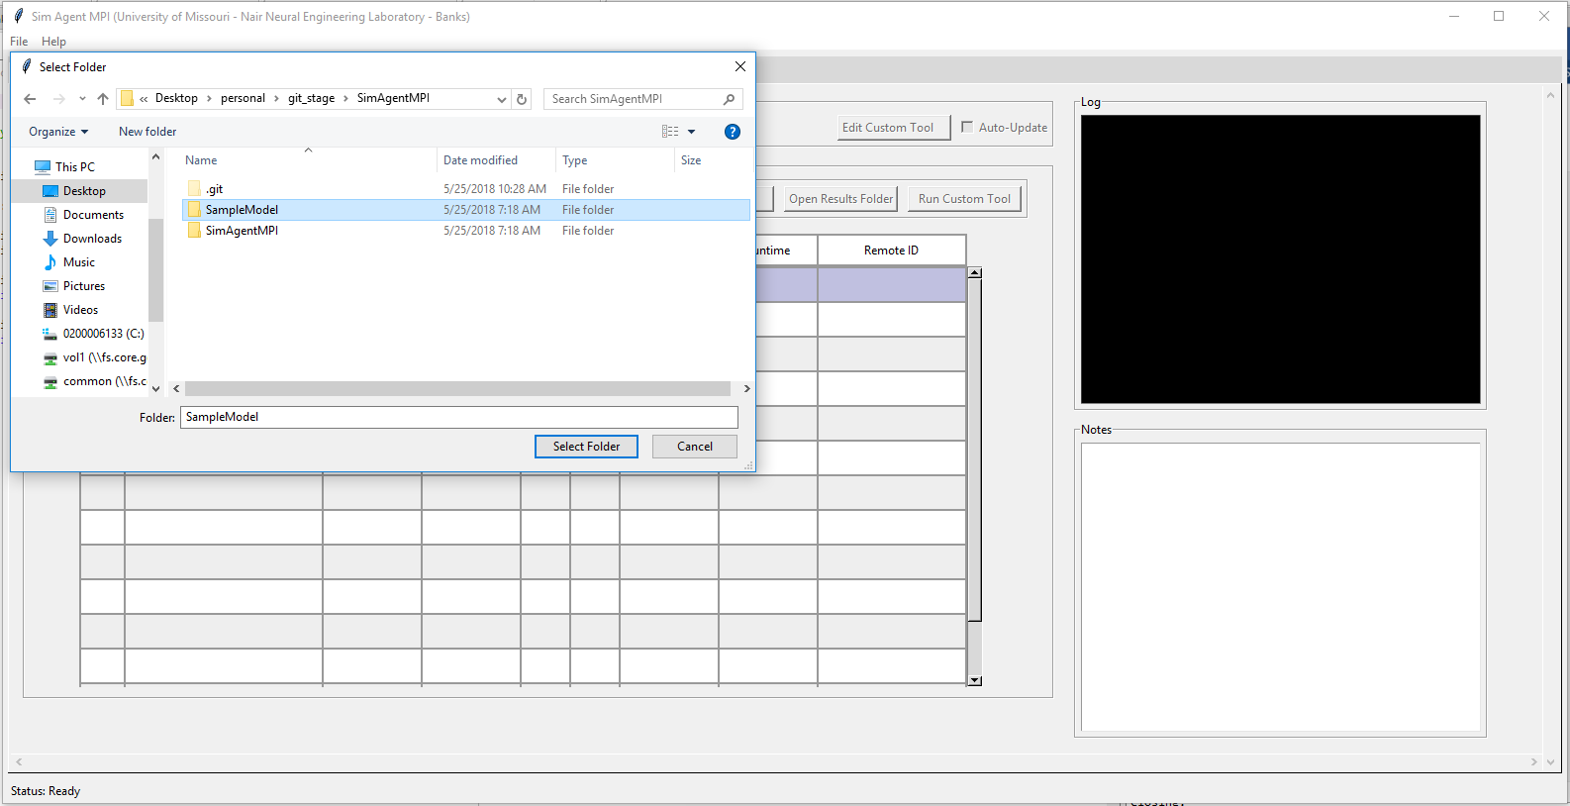

1. If the directory has not been used by **Sim Agent MPI** before it will prompt you. Click ‘Yes’.

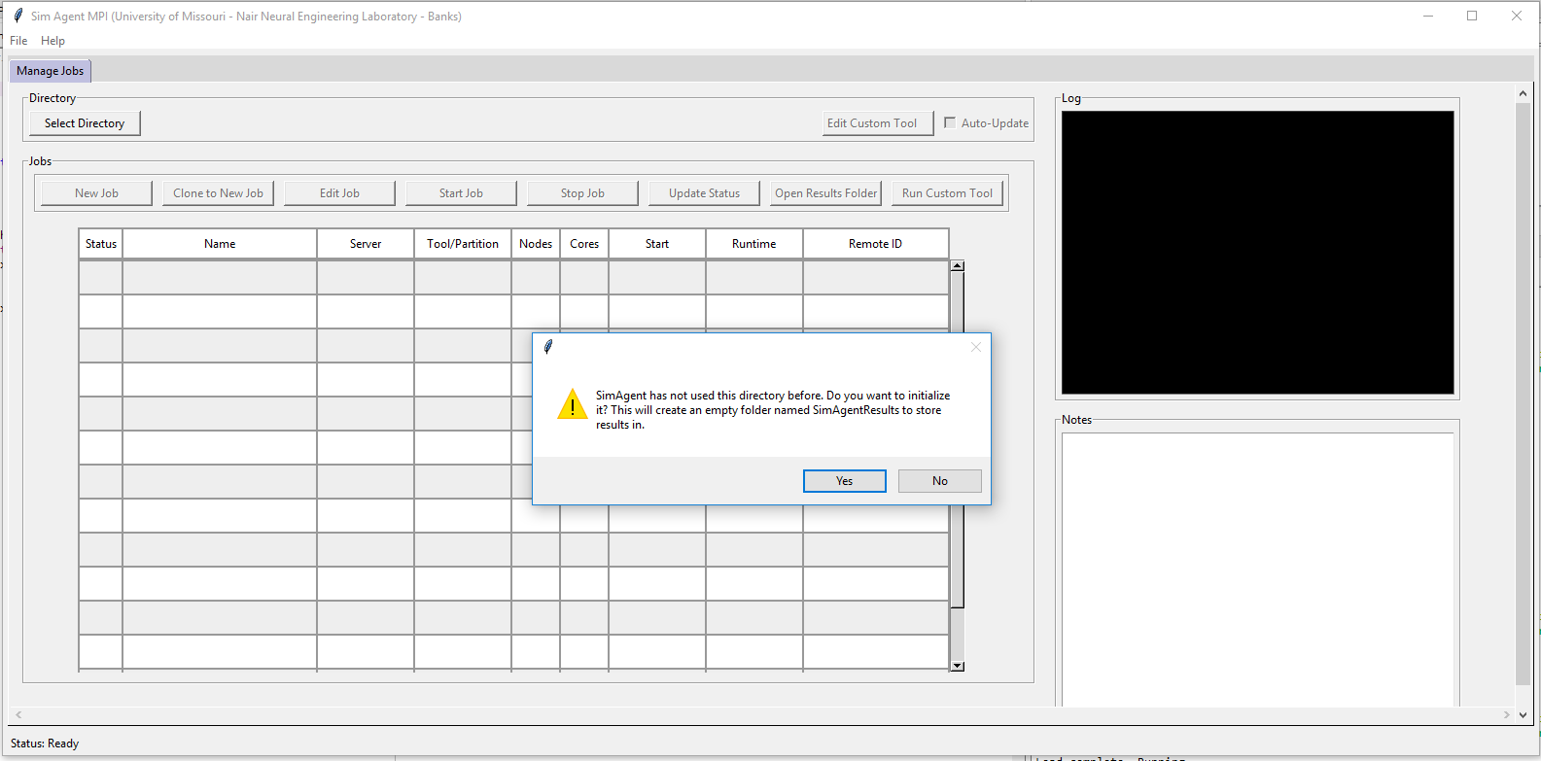

1. The ‘New Job’ button is now available. Click it to open the New Job Window. (Shown below)

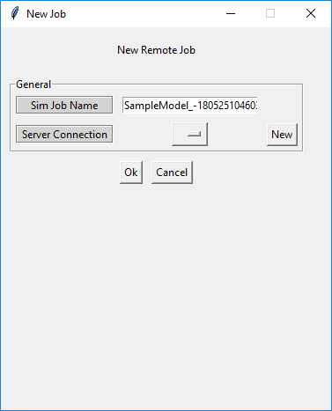

1. From here you’ll be able to set the name for your new job. Directories are created in the SimAgentResults folder with this name. If no options appear in the ‘Server Connection’ dropdown, create a new Server Connection by clicking “New”
   1. The Add/Edit Server Connection window will appear (shown below)
   2. You’ll have the option to set the Server name, NSG or SSH and parameters
   3. For an NSG Connection you’ll need a developer App from NSG-R (see guide below)
   4. Fill out the parameters and click ‘Ok’ (SSH default port is 22 and Base API URL is given)

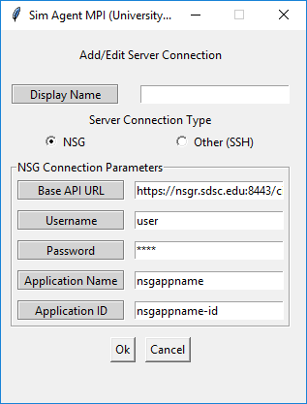 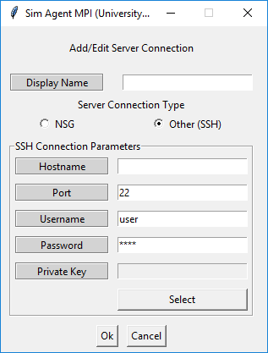

1. From the ‘New Job’ window select from a previously used (or new) server from the dropdown.

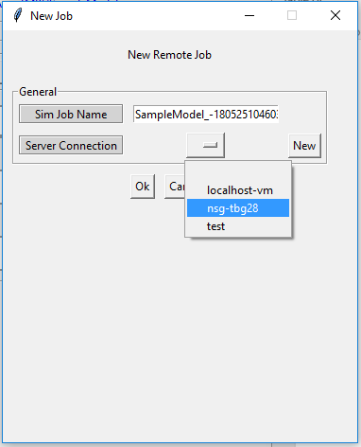

1. If you’ve selected an NSG connection (left) the following parameters will appear. SSH (right) Fill the required fields out and click ‘Ok’

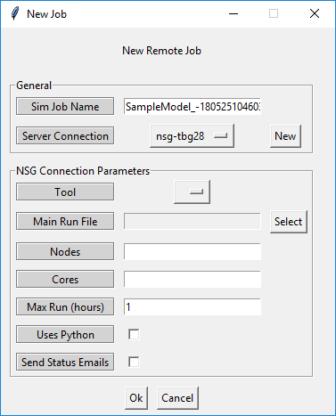 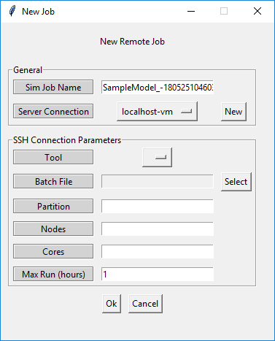

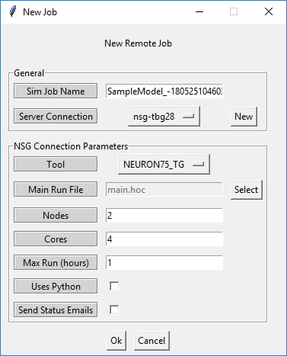 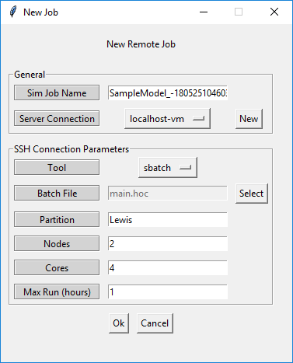

1. Your new job will appear in the ‘Jobs’ table. New jobs are denoted by yellow stars.

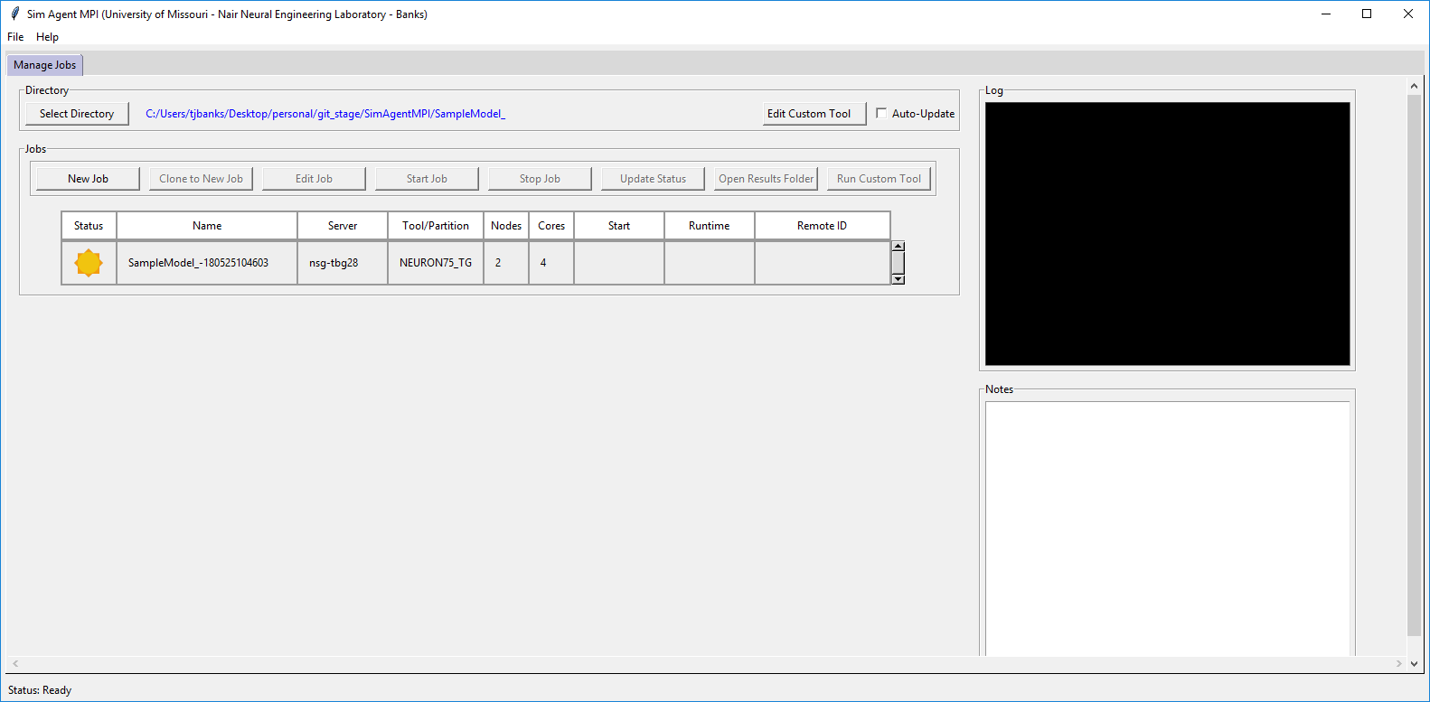

1. Select your job to view log information and take notes (parameters used etc.).

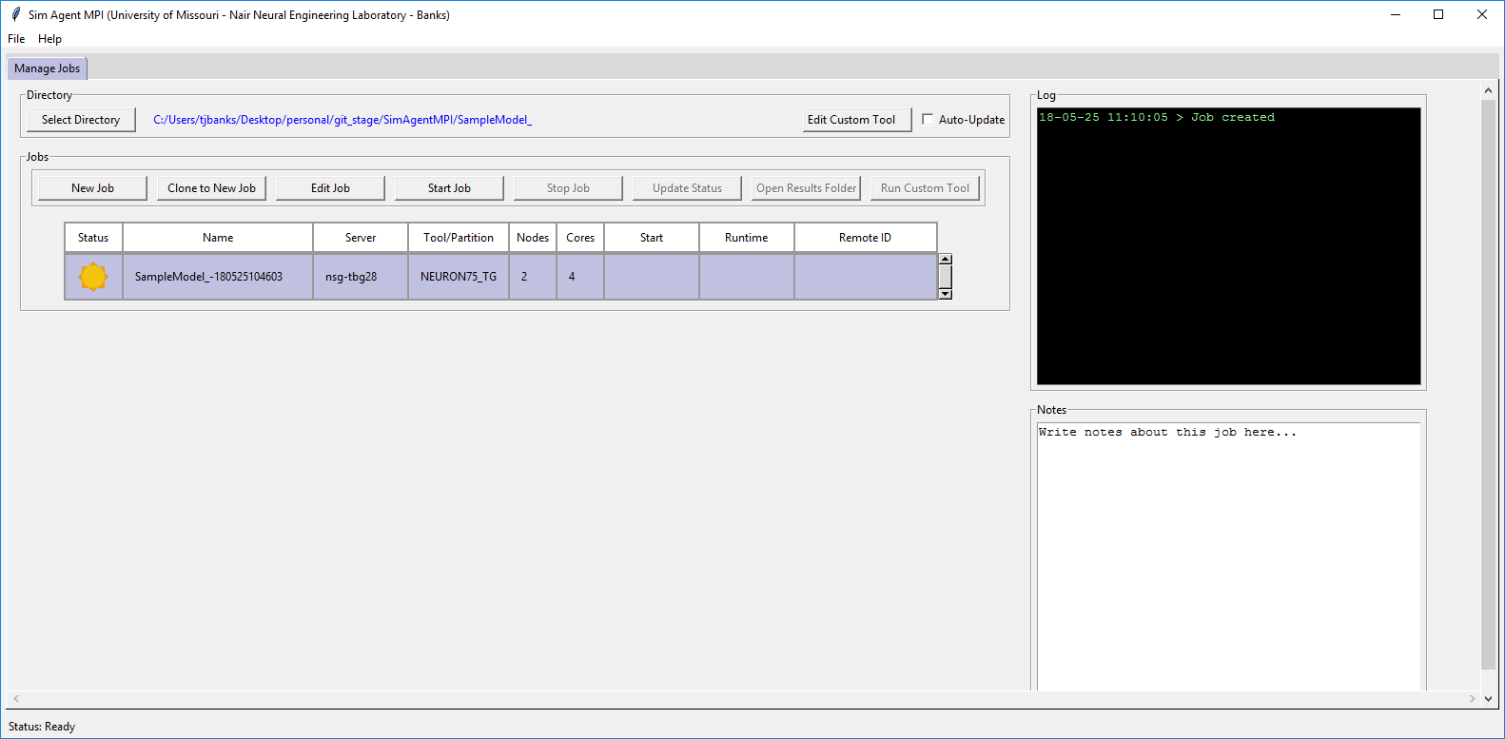

1. Your job is now ready to be started. You can edit the parameters by clicking ‘Edit Job’ any time before starting the job or after a failed job. You cannot edit the parameters while a job is running or after a successful run. Click ‘Start Job’ when you’re ready. A popup will confirm your choice. Click ‘Yes’

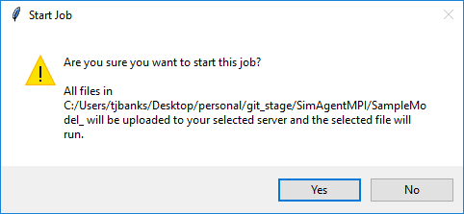

1. Your job is now in a running state and will be periodically checked (every 60 seconds by default) for changes while the “Auto-Update” checkbox is checked. The blue refresh icon is displayed next to your currently running job. You will only be able to ‘Stop Job’ or ‘Clone to New Job’ in this state.

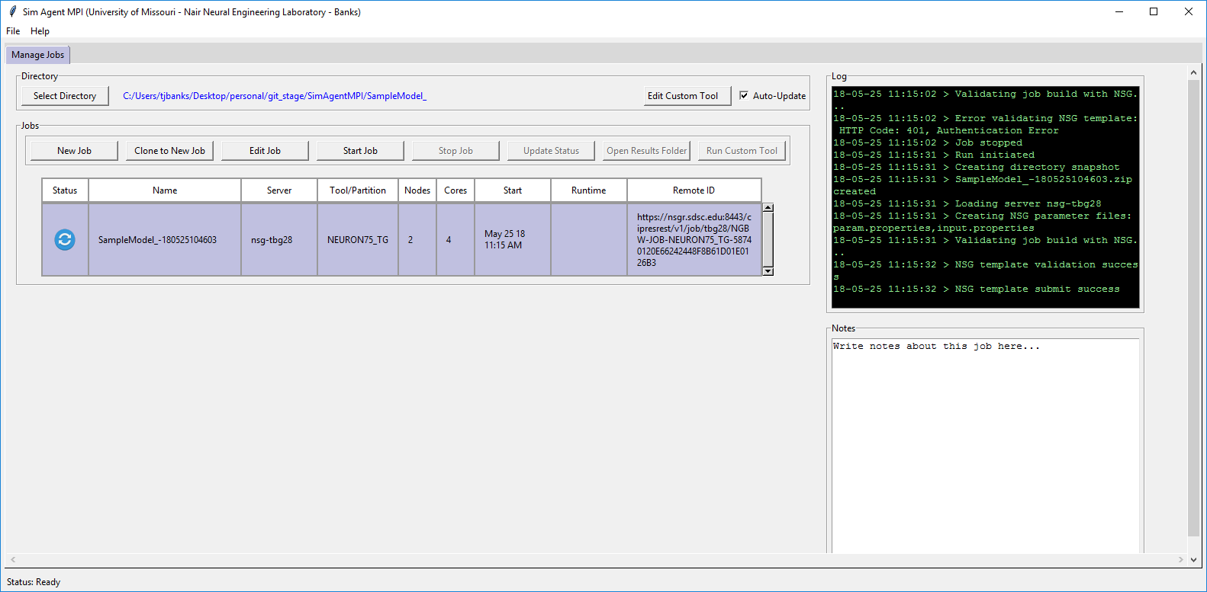

1. Upon completion, a green checkbox will appear next to your job. The results will be automatically downloaded to your results folder and immediately viewable.

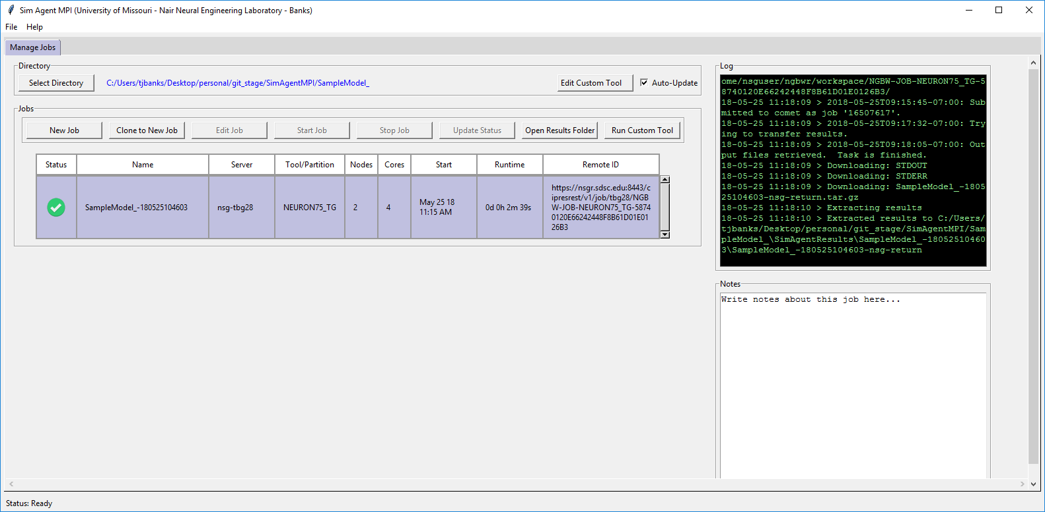

1. From here you can open the results folder by clicking ‘Open Results Folder’ or (optional) run a custom tool such as Matlab script to visualize the returned data by using the ‘Custom Tools’.
   1. To do so, click ‘Edit Custom Tool’
   2. A window (below) will appear with instructions. All commands are issued from a virtual command prompt prepended with the start command. The command will be executed from the results directory.

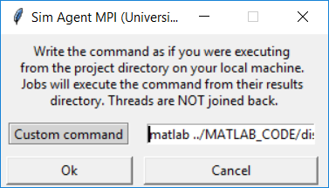

* 1. Run the command by selecting your job and clicking ‘Run Custom Tool’.

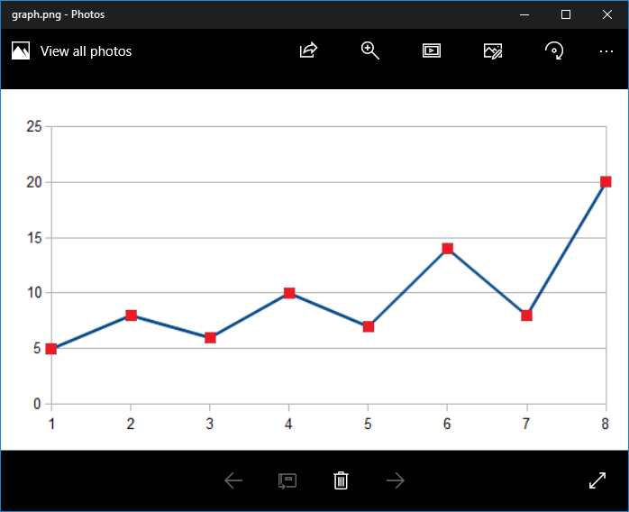

1. Finally, if at any point a job fails you’ll see a red X next to your job. See the log for more information.

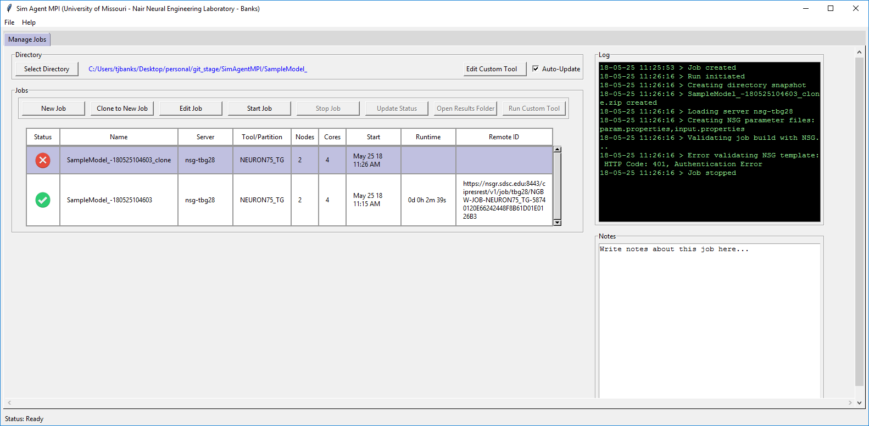

# Notes

1. You cannot delete anything from the GUI. This is intentional. To forget a job delete it from the SimAgentResults folder and re-select your directory.

# Obtaining an NSG-R account with API access

1. Register for an account on NSG at <https://www.nsgportal.org/gest/reg.php>
2. From the homepage click Access NSG-R at the bottom
3. Click on the developer dropdown and select ‘Application Management’
4. Create new application
5. Fill in the required application information and copy down the ‘Name’ and ‘Application ID’
6. You’ll use this information the when creating new Servers in **Sim Agent MPI**